UNITED STATES
SECURITIES AND EXCHANGE COMMISSION
Washington, D.C. 20549
FORM 8-K

CURRENT REPORT

Pursuant to Section 13 or 15(d) of The Securities Exchange Act of 1934

Date of Report (Date of earliest event reported): July 31, 2026

PORTLAND GENERAL ELECTRIC COMPANY
(Exact name of registrant as specified in its charter)
Oregon | 001-5532-99 | 93-0256820
(State or other jurisdiction  of incorporation) | (Commission  File Number) | (I.R.S. Employer  Identification No.)
121 SW Salmon Street, Portland, Oregon 97204
(Address of principal executive offices, including zip code)

Registrant’s telephone number, including area code: (503) 464-8000
Check the appropriate box below if the Form 8-K filing is intended to simultaneously satisfy the filing obligation of the registrant under any of the following provisions:
☐ Written communications pursuant to Rule 425 under the Securities Act (17 CFR 230.425)
☐ Soliciting material pursuant to Rule 14a-12 under the Exchange Act (17 CFR 240.14a-12)
☐ Pre-commencement communications pursuant to Rule 14d-2(b) under the Exchange Act (17 CFR 240.14d-2(b))
☐ Pre-commencement communications pursuant to Rule 13e-4(c) under the Exchange Act (17 CFR 240.13e-4(c))
Securities registered pursuant to Section 12(b) of the Act:
(Title of class) | (Trading Symbol) | (Name of exchange on which registered)
Common Stock, no par value | POR | New York Stock Exchange
Indicate by check mark whether the registrant is an emerging growth company as defined in Rule 405 of the Securities Act of 1933 or Rule 12b-2 of the Securities Exchange Act of 1934.

Emerging growth company ☐

If an emerging growth company, indicate by check mark if the registrant has elected not to use the extended transition period for complying with any new or revised financial accounting standards provided pursuant to Section 13(a) of the Exchange Act. [ ]

Item 2.02 Results of Operations and Financial Condition.

The following information is furnished pursuant to Item 2.02.

On July 31, 2026, Portland General Electric Company (the Company) issued a press release announcing its financial results for the three months ended June 30, 2026. The press release is furnished herewith as Exhibit 99.1 to this Report.

Item 7.01 Regulation FD Disclosure.

The following information is furnished pursuant to Item 7.01.

At 11:00 a.m. ET on Friday, July 31, 2026, the Company will hold its quarterly earnings call and webcast, and will use a slide presentation in conjunction with the earnings call. A copy of the slide presentation is furnished herewith as Exhibit 99.2 to this Report.

Item 9.01 Financial Statements and Exhibits.

(d) |  | Exhibits.
99.1 |  | Press release issued by Portland General Electric Company dated July 31, 2026.
99.2 |  | Portland General Electric Company Second Quarter 2026 Slides dated July 31, 2026.
104 |  | Cover Page Interactive Data File (embedded within the Inline XBRL document).

2

SIGNATURE

Pursuant to the requirements of the Securities Exchange Act of 1934, the registrant has duly caused this report to be signed on its behalf by the undersigned thereunto duly authorized.

 |  |  |  | PORTLAND GENERAL ELECTRIC COMPANY
 |  |  |  | (Registrant)
Date: | July 31, 2026 |  | By: | /s/ Joseph R. Trpik
 |  |  |  | Joseph R. Trpik
Senior Vice President, Finance
and Chief Financial Officer

3

Exhibit 99.1
 |  | Portland General Electric  One World Trade Center  121 S.W. Salmon Street  Portland, OR 97204  News Release
July 31, 2026
Media Contact: |  | Investor Contact:
Drew Hanson |  | Erin Schwartz
Corporate Communications |  | Investor Relations
Phone: 503-464-2067 |  | Phone: 503-464-7751

Portland General Electric Announces Second Quarter 2026 Results
•
Second quarter financial results were consistent with guidance and reflect strong operational execution
•
Industrial customer demand grew 11% year-over-year, driven by continued growth from high-tech and data center customers
•
Reaffirming 2026 adjusted earnings guidance of $3.33 to $3.53 per diluted share

PORTLAND, Oregon -- Portland General Electric Company (NYSE: POR) today reported second quarter 2026 net income of $68 million, or $0.59 per diluted share, on a generally accepted accounting principles (GAAP) basis. After adjusting for business transformation, optimization and acquisition expenses, second quarter 2026 non-GAAP net income was $74 million, or $0.64 per diluted share. This compares with second quarter 2025 GAAP net income of $62 million, or $0.56 per diluted share, and non-GAAP net income of $73 million, or $0.66 per diluted share.

"Affordability remains a national focus, and we have taken proactive steps to address customer cost pressures while supporting continued economic growth in our region. The approval of our large customer tariff reflects several years of legislative and regulatory work. It results in data center pricing increasing by approximately 30%, while lowering costs for all other customers," said Maria Pope, President and CEO. "As we enter the second half of 2026, we are focused on operational execution, meeting the opportunities of continued customer growth, and advancing major regulatory proceedings including our holding company and Washington acquisition filings."

Second Quarter 2026 Earnings Compared to Second Quarter 2025 Earnings
On a GAAP basis, total revenues increased due to higher cost recovery and increased energy deliveries, primarily driven by continued industrial load growth of 11.2%, while residential and commercial loads were relatively flat year over year. Purchased power and fuel expense increased due to expected intra-year timing differences between power cost recognition and revenue collections. Operations and maintenance expense decreased, reflecting ongoing cost management efforts, while depreciation and interest expense increased due to continued capital investment in the system.

Page 1

Additional Company Updates
Regulatory Update
The New Large Load Tariff (docket UM 2377) was approved by the OPUC in May 2026 and established a new rate class for large load customers. It also established an important framework that better aligns infrastructure costs with the customers driving new system growth while helping reduce costs for residential and small business customers. New prices became effective July 8, 2026, which included an average rate increase of approximately 30% for data center and other new large load customers, while lowering rates for all other customers.
Corporate Structure / Holding Company Update
PGE continued to advance its proposed holding company structure, with OPUC Staff recommending approval of the proposal, subject to certain conditions. The proposed structure is expected to enhance financing flexibility and support continued investment in clean energy, reliability, and infrastructure needed to serve customers over time.

General Rate Case
Next week, PGE will file its 2027 general rate case with the OPUC. As proposed, the case would result in an approximate 4.8% overall increase relative to currently approved prices. If approved, new rates would take effect July 1, 2027. This increase is expected to be partially offset by lower net variable power costs in 2027, which are addressed separately through the Annual Power Cost Update Tariff, and are currently forecasted to reduce customer prices by approximately 2.4% beginning January 1, 2027.

2025 All-Source Request for Proposals
The OPUC acknowledged our 2025 RFP final shortlist on May 26, 2026, marking an important milestone in the resource procurement process. We are now moving into commercial negotiations and expect to execute contracts by early 2027, subject to final negotiations and Board approvals.
Quarterly Dividend
As previously announced, on July 24, 2026, the board of directors of Portland General Electric Company approved a quarterly common stock dividend of 55.125 cents per share. The quarterly dividend is payable on or before October 15, 2026 to shareholders of record at the close of business on September 25, 2026.
2026 Earnings Guidance
PGE is reaffirming its estimate for full-year 2026 adjusted earnings guidance of $3.33 to $3.53 per diluted share based on the following assumptions:
•
An increase in energy deliveries between 1.5% and 2.5%, weather adjusted;
•
Execution of power cost and financing plans;
•
Execution of operating cost management plan;
•
Normal temperatures in its utility service area for the remainder of the year;
•
Hydro conditions for the year that reflect current estimates;
Page 2

•
Wind generation based on five years of historical levels or forecast studies when historical data is not available;
•
Normal thermal plant operations;
•
Operating and maintenance expense between $810 million and $830 million which includes approximately $150 million of wildfire, vegetation management, deferral amortization and other expenses that are offset in other income statement lines and $26 million of business transformation, optimization and acquisition expenses and $4 million of regulatory deferral adjustments related to the January 2024 storm and 2024 reliability contingency event;
•
Depreciation and amortization expense between $570 million and $590 million;
•
Effective tax rate of 15% to 20%;
•
Cash from operations of $1,000 to $1,200 million;
•
Capital expenditures of $1,655 million; and
•
Average construction work in progress balance of $780 million.

Second Quarter 2026 Earnings Call and Webcast — July 31, 2026
PGE will host a conference call with financial analysts and investors on Friday, July 31, 2026, at 11 a.m. ET. The conference call will be webcast live on the PGE website at investors.portlandgeneral.com. A webcast replay will also be available on PGE's investor website “Events & Presentations” page beginning at 2 p.m. ET on July 31, 2026.

Maria Pope, President and CEO; Joe Trpik, Senior Vice President of Finance and CFO; and Erin Schwartz, Senior Manager of Investor Relations, will participate in the call. Management will respond to questions following formal comments.

Non-GAAP Financial Measures
This press release contains certain non-GAAP measures, such as adjusted earnings, adjusted EPS and adjusted earnings guidance. These non-GAAP financial measures exclude significant items that are generally not related to our ongoing business activities, are infrequent in nature, or both. PGE believes that excluding the effects of these items provides an alternative measure of the Company’s comparative earnings per share and enables investors to evaluate the Company’s operating financial performance trends, exclusive of items that are not normally associated with ongoing operations. Management utilizes non-GAAP measures to assess the Company’s current and forecasted performance, and for communications with shareholders, analysts and investors. Non-GAAP financial measures are supplementary information that should be considered in addition to, but not as a substitute for, the information prepared in accordance with GAAP.

Items in the periods presented, which PGE believes impact the comparability of comparative earnings and do not represent ongoing operating financial performance, include the following:

•
Business transformation and optimization expenses, including strategic advisory, workforce realignment, corporate structure update costs and Washington acquisition related expenses including legal, financing and strategic advisory costs.

Due to the forward-looking nature of PGE’s non-GAAP adjusted earnings guidance, and the inherently unpredictable nature of items and events which could lead to the recognition of non-GAAP adjustments (such as, but not limited to, regulatory disallowances or extreme weather events), management is unable to estimate the occurrence or value of specific items requiring adjustment for future periods, which could potentially impact the Company’s GAAP earnings. Therefore, management cannot provide a reconciliation of non-GAAP adjusted earnings per share guidance to the
Page 3

most comparable GAAP financial measure without unreasonable effort. For the same reasons, management is unable to address the probable significance of unavailable information.

PGE’s reconciliation of non-GAAP earnings for the quarters ended June 30, 2026 is below.

Non-GAAP Earnings Reconciliation for the quarter ended June 30, 2026
(Dollars in millions, except EPS) | Net Income | Diluted EPS
GAAP as reported for the quarter ended June 30, 2026 | $ 68 | $ 0.59
Exclusion of business transformation, optimization and acquisition expenses | 8 | 0.07
Tax effect (1) | (2) | (0.02)
Non-GAAP as reported for the quarter ended June 30, 2026 | $ 74 | $ 0.64

(1) Tax effects were determined based on the Company’s full-year blended federal and state statutory rate.

# # #

About Portland General Electric Company
Portland General Electric (NYSE: POR) is an integrated energy company that generates, transmits and distributes electricity to nearly 960,000 customers serving an area of approximately 2 million Oregonians. Since 1889, Portland General Electric (PGE) has been powering economies, delivering safe, affordable and reliable electricity while working to transform energy systems to meet evolving customer needs. PGE continues to make progress towards emissions reduction targets, and customers have set the standard for prioritizing clean energy with the No. 1 voluntary renewable energy program in the country. PGE is ranked a top ten utility in the 2025 Forrester U.S. Customer Experience Index. In 2025, PGE employees and retirees volunteered over 18,300 hours to more than 400 nonprofits organizations. Through the PGE Foundation, along with corporate contributions and the employee matching gift program, more than $5 million was directed to charitable organizations supporting economic growth and community resilience across our service area. For information: portlandgeneral.com/news.

Safe Harbor Statement
Statements in this press release that relate to future plans, objectives, expectations, performance, events and the like may constitute “forward-looking statements” within the meaning of the Private Securities Litigation Reform Act of 1995, Section 27A of the Securities Act of 1933, as amended, and Section 21E of the Securities Exchange Act of 1934, as amended. These forward-looking statements represent our estimates and assumptions as of the date of this report, and PGE assumes no obligation to update or revise any forward-looking statement as a result of new information, future events or other factors. Investors should not rely unduly on any forward-looking statements.
Forward-looking statements include statements, other than statements of historical or current fact, regarding PGE's earnings guidance (including all the assumptions and expectations upon which such guidance is based), PGE's proposed purchase of electric utility operations and certain assets in Washington state from PacifiCorp (Acquisition), and PGE's operating and financing plans, as well as other statements containing words such as “anticipates,” “assumptions,” “believes,” “continue,” “could,” “estimates,” “expected,” “forecast,” “guidance,” “may,” “plans,” “proposed,” “seeks,” “should,” “will,” “working to,” or similar expressions.

Forward-looking statements are inherently subject to risks and uncertainties, some of which cannot be predicted or quantified, which could cause future events and actual results to differ materially from those set forth in, contemplated by, or underlying the forward-looking statements. Such risks, uncertainties and other factors include, without
Page 4

limitation: wildfire and public safety risks, including ignitions caused by PGE assets, the effectiveness of wildfire mitigation, vegetation management, and system hardening, the ability to implement public safety power shutoffs (PSPS), related liability exposure, and the timing and extent of regulatory cost recovery; severe weather, climate, and catastrophe risks, including extreme or unseasonable weather and other natural or human caused disasters that could endanger public safety, disrupt operations, damage assets, limit access to power or fuel supplies, increase costs, or adversely affect cost recovery; electric system operational risks, including forced outages, fires, equipment failures, adverse hydro or wind conditions, fuel supply disruptions, and complications at jointly owned facilities, resulting in increased costs or the need to procure replacement power; power and fuel supply and price risks, including availability, counterparty nonperformance, and volatility in wholesale electricity, natural gas, coal, and other fuel markets; regulatory, legislative, and policy risks, including new or revised laws, regulations, executive actions, audits, investigations, and proceedings that could affect rates, cost recovery, operations, capital plans, or financial results; Acquisition risks, including risks related to regulatory approvals, financing and joint-venture arrangements, integration and operational execution, cost recovery, and the possibility that the anticipated benefits of the Acquisition are delayed, not realized, or cost more than expected; environmental compliance and permitting risks, including evolving environmental laws and permitting requirements and site specific remediation obligations, such as Superfund liabilities, where uncertainties regarding remediation scope, cost allocation, litigation, and regulatory cost recovery could result in material costs or adversely affect PGE’s financial position, results of operations, or cash flows; capital investment and execution risks, including supply chain disruptions, cost inflation, labor constraints, permitting delays, contractual disputes, counterparty failures, or project abandonment, which could impair timely completion or cost recovery; load growth and demand uncertainty, including accelerated or uneven growth from large customers such as data centers, changes in customer usage patterns, variability in demand driven by weather variations, and reduced consumption or load shifting resulting from price increases, energy efficiency measures or other changes in customer behavior; customer choice and market structure risks, including reduced demand or usage shifts due to distributed generation or increased procurement from alternative providers, such as registered Electricity Service Suppliers (ESSs) or community choice aggregation programs; cybersecurity and physical security risks, including cyberattacks, data breaches, physical attacks, the use or misuse of artificial intelligence technologies, or other malicious acts that could damage assets, disrupt systems, or result in the disclosure of sensitive information; geopolitical and macroeconomic risks, including acts of war, terrorism, or civil unrest—such as the escalation of US operations in the Middle East—that could disrupt energy markets or supply chains, increase costs, or contribute to volatility in capital markets, inflation, or interest rates; economic and financial market risks, including availability and cost of capital, interest rate and equity market volatility, inflation, and trade tariffs affecting operating or capital costs; legal and litigation risks, including the timing and outcome of judicial, administrative, or regulatory proceedings, which may result in material liabilities or costs; workforce and labor risks, including labor strikes, work stoppages, collective bargaining disputes, the ability to attract and retain skilled employees, and transitions in senior management; resource procurement and All-Source Request for Proposals (RFP) project risks, including uncertainties related to the availability, cost, permitting, financing, and performance of resources selected through RFP or other regulatory processes and associated regulatory and counterparty risks; insurance availability and cost, particularly for wildfire or catastrophe related coverage; accounting, tax, and policy changes, including changes in accounting standards, tax laws, or regulatory accounting policies that could affect reported results or cash flows; and the other risks and uncertainties set forth in PGE’s Annual Report on Form 10-K for the year ended December 31, 2025, as filed with the SEC.

Source: Portland General Electric Company
Page 5

PORTLAND GENERAL ELECTRIC COMPANY AND SUBSIDIARIES
CONDENSED CONSOLIDATED STATEMENTS OF INCOME
(Dollars in millions, except per share amounts)
(Unaudited)

 |  | Three Months Ended June 30, |  |  |  |  |  |  |  | Six Months Ended June 30,
 |  | 2026 |  |  |  | 2025 |  |  |  | 2026 |  |  |  | 2025
Revenues:
Revenues, net |  | $ | 811 |  |  | $ | 798 |  |  | $ | 1,674 |  |  | $ | 1,730
Alternative revenue programs, net of amortization |  |  | 3 |  |  |  | 9 |  |  |  | 19 |  |  |  | 5
Total revenues |  |  | 814 |  |  |  | 807 |  |  |  | 1,693 |  |  |  | 1,735
Operating expenses:
Purchased power and fuel |  |  | 296 |  |  |  | 294 |  |  |  | 657 |  |  |  | 662
Generation, transmission and distribution |  |  | 112 |  |  |  | 114 |  |  |  | 222 |  |  |  | 224
Administrative and other |  |  | 90 |  |  |  | 96 |  |  |  | 196 |  |  |  | 192
Depreciation and amortization |  |  | 143 |  |  |  | 139 |  |  |  | 287 |  |  |  | 279
Taxes other than income taxes |  |  | 52 |  |  |  | 46 |  |  |  | 103 |  |  |  | 92
Total operating expenses |  |  | 693 |  |  |  | 689 |  |  |  | 1,465 |  |  |  | 1,449
Income from operations |  |  | 121 |  |  |  | 118 |  |  |  | 228 |  |  |  | 286
Interest expense, net |  |  | 61 |  |  |  | 57 |  |  |  | 121 |  |  |  | 113
Other income:
Allowance for equity funds used during construction |  |  | 6 |  |  |  | 6 |  |  |  | 9 |  |  |  | 11
Miscellaneous income, net |  |  | 14 |  |  |  | 7 |  |  |  | 18 |  |  |  | 12
Other income, net |  |  | 20 |  |  |  | 13 |  |  |  | 27 |  |  |  | 23
Income before income tax expense |  |  | 80 |  |  |  | 74 |  |  |  | 134 |  |  |  | 196
Income tax expense |  |  | 12 |  |  |  | 12 |  |  |  | 21 |  |  |  | 34
Net income and Comprehensive income |  | $ | 68 |  |  | $ | 62 |  |  | $ | 113 |  |  | $ | 162
Weighted-average common shares outstanding (in thousands):
Basic |  |  | 115,733 |  |  |  | 109,522 |  |  |  | 115,687 |  |  |  | 109,473
Diluted |  |  | 116,376 |  |  |  | 109,765 |  |  |  | 116,285 |  |  |  | 109,725
Earnings per share:
Basic |  | $ | 0.59 |  |  | $ | 0.56 |  |  | $ | 0.97 |  |  | $ | 1.48
Diluted |  | $ | 0.59 |  |  | $ | 0.56 |  |  | $ | 0.97 |  |  | $ | 1.47

Page 6

PORTLAND GENERAL ELECTRIC COMPANY AND SUBSIDIARIES
CONDENSED CONSOLIDATED BALANCE SHEETS
(In millions)
(Unaudited)
 |  | June 30, 2026 |  |  |  | December 31, 2025
ASSETS
Current assets:
Cash and cash equivalents |  | $ | 35 |  |  | $ | 76
Accounts receivable, net |  |  | 410 |  |  |  | 460
Inventories |  |  | 126 |  |  |  | 124
Regulatory assets—current |  |  | 255 |  |  |  | 168
Other current assets |  |  | 218 |  |  |  | 244
Total current assets |  |  | 1,044 |  |  |  | 1,072
Electric utility plant, net |  |  | 11,535 |  |  |  | 10,993
Regulatory assets—noncurrent |  |  | 521 |  |  |  | 619
Nuclear decommissioning trust |  |  | 46 |  |  |  | 42
Non-qualified benefit plan trust |  |  | 38 |  |  |  | 36
Other noncurrent assets |  |  | 459 |  |  |  | 468
Total assets |  | $ | 13,643 |  |  | $ | 13,230

Page 7

PORTLAND GENERAL ELECTRIC COMPANY AND SUBSIDIARIES
CONDENSED CONSOLIDATED BALANCE SHEETS, continued
(In millions, except share amounts)
(Unaudited)

 |  | June 30, 2026 |  |  |  | December 31, 2025
LIABILITIES AND SHAREHOLDERS’ EQUITY
Current liabilities:
Accounts payable |  | $ | 451 |  |  | $ | 330
Liabilities from price risk management activities—current |  |  | 140 |  |  |  | 158
Current portion of finance lease obligation |  |  | 27 |  |  |  | 27
Accrued expenses and other current liabilities |  |  | 451 |  |  |  | 478
Total current liabilities |  |  | 1,069 |  |  |  | 993
Long-term debt, net of current portion |  |  | 4,928 |  |  |  | 4,662
Regulatory liabilities—noncurrent |  |  | 1,507 |  |  |  | 1,490
Deferred income taxes |  |  | 639 |  |  |  | 601
Deferred investment tax credits |  |  | 190 |  |  |  | 194
Unfunded status of pension and postretirement plans |  |  | 94 |  |  |  | 107
Liabilities from price risk management activities—noncurrent |  |  | 66 |  |  |  | 56
Asset retirement obligations |  |  | 301 |  |  |  | 299
Non-qualified benefit plan liabilities |  |  | 67 |  |  |  | 70
Finance lease obligations, net of current portion |  |  | 256 |  |  |  | 263
Other noncurrent liabilities |  |  | 403 |  |  |  | 362
Total liabilities |  |  | 9,520 |  |  |  | 9,097
Commitments and contingencies (see notes)
Shareholders’ Equity:
Preferred stock, no par value, 30,000,000 shares authorized; none issued and outstanding as of June 30, 2026 and December 31, 2025 |  |  | — |  |  |  | —
Common stock, no par value, 160,000,000 shares authorized; 115,785,254 and 115,559,079 shares issued and outstanding as of June 30, 2026 and December 31, 2025, respectively |  |  | 2,385 |  |  |  | 2,382
Accumulated other comprehensive loss |  |  | (4 | ) |  |  | (4 | )
Retained earnings |  |  | 1,742 |  |  |  | 1,755
Total shareholders’ equity |  |  | 4,123 |  |  |  | 4,133
Total liabilities and shareholders’ equity |  | $ | 13,643 |  |  | $ | 13,230

Page 8

PORTLAND GENERAL ELECTRIC COMPANY AND SUBSIDIARIES
CONDENSED CONSOLIDATED STATEMENTS OF CASH FLOWS
(In millions)
(Unaudited)

 |  | Six Months Ended June 30,
 |  | 2026 |  |  |  | 2025
Cash flows from operating activities:
Net income |  | $ | 113 |  |  | $ | 162
Adjustments to reconcile net income to net cash provided by operating activities:
Depreciation and amortization |  |  | 287 |  |  |  | 279
Deferred income taxes |  |  | 13 |  |  |  | 25
Allowance for equity funds used during construction |  |  | (9 | ) |  |  | (11 | )
Alternative revenue programs |  |  | (19 | ) |  |  | (5 | )
Regulatory assets |  |  | 3 |  |  |  | (3 | )
Regulatory liabilities |  |  | 4 |  |  |  | (16 | )
Tax credit sales |  |  | 12 |  |  |  | 13
Other non-cash income and expenses, net |  |  | 61 |  |  |  | 49
Changes in working capital:
Accounts receivable, net |  |  | 47 |  |  |  | 52
Inventories |  |  | (2 | ) |  |  | (9 | )
Margin deposits |  |  | 50 |  |  |  | 85
Accounts payable and accrued liabilities |  |  | (53 | ) |  |  | (35 | )
Margin deposits from wholesale counterparties |  |  | 8 |  |  |  | —
Other working capital items, net |  |  | 12 |  |  |  | 22
Other, net |  |  | (39 | ) |  |  | (41 | )
Net cash provided by operating activities |  |  | 488 |  |  |  | 567
Cash flows from investing activities:
Capital expenditures |  |  | (635 | ) |  |  | (596 | )
Sales of Nuclear decommissioning trust securities |  |  | 3 |  |  |  | 1
Purchases of Nuclear decommissioning trust securities |  |  | (3 | ) |  |  | (3 | )
Other, net |  |  | (15 | ) |  |  | (11 | )
Net cash used in investing activities |  |  | (650 | ) |  |  | (609 | )

Page 9

PORTLAND GENERAL ELECTRIC COMPANY AND SUBSIDIARIES
CONDENSED CONSOLIDATED STATEMENTS OF CASH FLOWS, continued
(In millions)
(Unaudited)

 |  | Six Months Ended June 30,
 |  | 2026 |  |  |  | 2025
Cash flows from financing activities:
Proceeds from issuance of long-term debt |  | $ | 270 |  |  | $ | 310
Payments on long-term debt |  |  | — |  |  |  | (102 | )
Dividends paid |  |  | (120 | ) |  |  | (109 | )
Other |  |  | (29 | ) |  |  | (13 | )
Net cash provided by financing activities |  |  | 121 |  |  |  | 86
Change in cash and cash equivalents |  |  | (41 | ) |  |  | 44
Cash and cash equivalents, beginning of period |  |  | 76 |  |  |  | 12
Cash and cash equivalents, end of period |  | $ | 35 |  |  | $ | 56
Supplemental cash flow information is as follows:
Cash paid for interest, net of amounts capitalized |  | $ | 103 |  |  | $ | 94
Cash received for income taxes, net |  |  | (2 | ) |  |  | (3 | )

Page 10

PORTLAND GENERAL ELECTRIC COMPANY AND SUBSIDIARIES
SUPPLEMENTAL OPERATING STATISTICS
(Unaudited)

 |  | Three Months Ended June 30, |  |  |  |  |  |  |  |  |  |  |  |  |  |  |  | Six Months Ended June 30,
 |  | 2026 |  |  |  |  |  |  |  | 2025 |  |  |  |  |  |  |  | 2026 |  |  |  |  |  |  |  | 2025
Retail:
Residential |  | $ | 334 |  |  |  | 41 | % |  | $ | 311 |  |  |  | 39 | % |  | $ | 728 |  |  |  | 43 | % |  | $ | 740 |  |  |  | 43 | %
Commercial |  |  | 248 |  |  |  | 31 |  |  |  | 234 |  |  |  | 29 |  |  |  | 483 |  |  |  | 29 |  |  |  | 476 |  |  |  | 27
Industrial |  |  | 156 |  |  |  | 19 |  |  |  | 128 |  |  |  | 16 |  |  |  | 295 |  |  |  | 17 |  |  |  | 255 |  |  |  | 15
Subtotal |  |  | 738 |  |  |  | 91 |  |  |  | 673 |  |  |  | 84 |  |  |  | 1,506 |  |  |  | 89 |  |  |  | 1,471 |  |  |  | 85
Direct access:
Commercial |  |  | 4 |  |  |  | — |  |  |  | 4 |  |  |  | — |  |  |  | 7 |  |  |  | — |  |  |  | 8 |  |  |  | —
Industrial |  |  | 8 |  |  |  | 1 |  |  |  | 6 |  |  |  | 1 |  |  |  | 14 |  |  |  | 1 |  |  |  | 11 |  |  |  | 1
Subtotal |  |  | 12 |  |  |  | 1 |  |  |  | 10 |  |  |  | 1 |  |  |  | 21 |  |  |  | 1 |  |  |  | 19 |  |  |  | 1
Subtotal Retail |  |  | 750 |  |  |  | 92 |  |  |  | 683 |  |  |  | 85 |  |  |  | 1,527 |  |  |  | 90 |  |  |  | 1,490 |  |  |  | 86
Alternative revenue programs, net of amortization |  |  | 3 |  |  |  | 0 |  |  |  | 9 |  |  |  | 1 |  |  |  | 19 |  |  |  | 1 |  |  |  | 5 |  |  |  | —
Other accrued revenues, net |  |  | (2 | ) |  |  | — |  |  |  | 6 |  |  |  | — |  |  |  | (5 | ) |  |  | — |  |  |  | 10 |  |  |  | 1
Total retail revenues |  |  | 751 |  |  |  | 92 |  |  |  | 698 |  |  |  | 86 |  |  |  | 1,541 |  |  |  | 91 |  |  |  | 1,505 |  |  |  | 87
Wholesale revenues |  |  | 39 |  |  |  | 5 |  |  |  | 88 |  |  |  | 11 |  |  |  | 102 |  |  |  | 6 |  |  |  | 188 |  |  |  | 11
Other operating revenues |  |  | 24 |  |  |  | 3 |  |  |  | 21 |  |  |  | 3 |  |  |  | 50 |  |  |  | 3 |  |  |  | 42 |  |  |  | 2
Total revenues |  | $ | 814 |  |  |  | 100 | % |  | $ | 807 |  |  |  | 100 | % |  | $ | 1,693 |  |  |  | 100 | % |  | $ | 1,735 |  |  |  | 100 | %

 |  | Three Months Ended June 30, |  |  |  |  |  |  |  |  |  |  |  |  |  |  |  | Six Months Ended June 30,
 |  | 2026 |  |  |  | 2025 |  |  |  | %  Change |  |  |  | % Change (Weather- Adjusted) |  |  |  | 2026 |  |  |  | 2025 |  |  |  | %  Change |  |  |  | % Change (Weather- Adjusted)*
Energy deliveries:
Retail:
Residential |  |  | 1,591 |  |  |  | 1,571 |  |  |  | 1.3 | % |  |  | (1.4 | )% |  |  | 3,678 |  |  |  | 3,797 |  |  |  | (3.1 | )% |  |  | (3.3 | )%
Commercial |  |  | 1,529 |  |  |  | 1,546 |  |  |  | (1.1 | ) |  |  | (2.0 | ) |  |  | 3,123 |  |  |  | 3,178 |  |  |  | (1.7 | ) |  |  | (1.8 | )
Industrial |  |  | 1,633 |  |  |  | 1,416 |  |  |  | 15.3 |  |  |  | 15.2 |  |  |  | 3,161 |  |  |  | 2,814 |  |  |  | 12.3 |  |  |  | 12.3
Subtotal |  |  | 4,753 |  |  |  | 4,533 |  |  |  | 4.9 |  |  |  | 3.5 |  |  |  | 9,962 |  |  |  | 9,789 |  |  |  | 1.8 |  |  |  | 1.6
Direct access:
Commercial |  |  | 118 |  |  |  | 135 |  |  |  | (12.6 | ) |  |  | (12.6 | ) |  |  | 234 |  |  |  | 264 |  |  |  | (11.4 | ) |  |  | (11.4 | )
Industrial |  |  | 513 |  |  |  | 513 |  |  |  | — |  |  |  | — |  |  |  | 1,010 |  |  |  | 956 |  |  |  | 5.6 |  |  |  | 5.6
Subtotal |  |  | 631 |  |  |  | 648 |  |  |  | (2.6 | ) |  |  | (2.6 | ) |  |  | 1,244 |  |  |  | 1,220 |  |  |  | 2.0 |  |  |  | 2.0
Total retail |  |  | 5,384 |  |  |  | 5,181 |  |  |  | 3.9 |  |  |  | 2.7 | % |  |  | 11,206 |  |  |  | 11,009 |  |  |  | 1.8 |  |  |  | 1.7 | %
Wholesale |  |  | 1,515 |  |  |  | 2,439 |  |  |  | (37.9 | ) |  |  |  |  |  |  | 2,914 |  |  |  | 4,418 |  |  |  | (34.0 | )
Total |  |  | 6,899 |  |  |  | 7,620 |  |  |  | (9.5 | )% |  |  |  |  |  |  | 14,120 |  |  |  | 15,427 |  |  |  | (8.5 | )%

Page 11

 |  | Three Months Ended June 30, |  |  |  |  |  |  |  |  |  |  |  | Six Months Ended June 30,
 |  | 2026 |  |  |  | 2025 |  |  |  | % Change |  |  |  | 2026 |  |  |  | 2025 |  |  |  | % Change
Average number of retail customers:
Residential |  |  | 846,367 |  |  |  | 839,923 |  |  |  | 1 | % |  |  | 845,926 |  |  |  | 838,516 |  |  |  | 1 | %
Commercial |  |  | 114,523 |  |  |  | 114,230 |  |  |  | — |  |  |  | 114,533 |  |  |  | 114,211 |  |  |  | —
Industrial |  |  | 222 |  |  |  | 218 |  |  |  | 2 |  |  |  | 221 |  |  |  | 217 |  |  |  | 2
Direct access |  |  | 502 |  |  |  | 729 |  |  |  | (31 | ) |  |  | 518 |  |  |  | 659 |  |  |  | (21 | )
Total |  |  | 961,614 |  |  |  | 955,100 |  |  |  | 1 | % |  |  | 961,198 |  |  |  | 953,603 |  |  |  | 1 | %

Page 12

PORTLAND GENERAL ELECTRIC COMPANY AND SUBSIDIARIES
SUPPLEMENTAL OPERATING STATISTICS, continued
(Unaudited)

 |  | Heating Degree-days |  |  |  |  |  |  |  |  |  |  |  | Cooling Degree-days
 |  | 2026 |  |  |  | 2025 |  |  |  | Avg. |  |  |  | 2026 |  |  |  | 2025 |  |  |  | Avg.
First Quarter |  |  | 1,737 |  |  |  | 1,772 |  |  |  | 1,828 |  |  |  | — |  |  |  | 4 |  |  |  | —
April |  |  | 303 |  |  |  | 248 |  |  |  | 349 |  |  |  | — |  |  |  | — |  |  |  | 3
May |  |  | 122 |  |  |  | 160 |  |  |  | 169 |  |  |  | 27 |  |  |  | 14 |  |  |  | 26
June |  |  | 52 |  |  |  | 56 |  |  |  | 62 |  |  |  | 106 |  |  |  | 88 |  |  |  | 86
Second Quarter |  |  | 477 |  |  |  | 464 |  |  |  | 580 |  |  |  | 133 |  |  |  | 102 |  |  |  | 115
Year-to-date |  |  | 2,214 |  |  |  | 2,236 |  |  |  | 2,408 |  |  |  | 133 |  |  |  | 106 |  |  |  | 115
(Decrease)/Increase from the 15-year average |  |  | (8 | )% |  |  | (7 | )% |  |  |  |  |  |  | 16 | % |  |  | (8 | )%
Note: “Average” amounts represent the 15-year rolling averages provided by the National Weather Service (Portland Airport).

 |  | Three Months Ended June 30, |  |  |  |  |  |  |  |  |  |  |  |  |  |  |  | Six Months Ended June 30,
 |  | 2026 |  |  |  |  |  |  |  | 2025 |  |  |  |  |  |  |  | 2026 |  |  |  |  |  |  |  | 2025
Generation:
Thermal:
Natural gas |  |  | 1,395 |  |  |  | 21 | % |  |  | 2,279 |  |  |  | 32 | % |  |  | 3,735 |  |  |  | 28 | % |  |  | 5,396 |  |  |  | 37 | %
Coal |  |  | 193 |  |  |  | 3 |  |  |  | 294 |  |  |  | 4 |  |  |  | 515 |  |  |  | 4 |  |  |  | 827 |  |  |  | 6
Total thermal |  |  | 1,588 |  |  |  | 24 |  |  |  | 2,573 |  |  |  | 36 |  |  |  | 4,250 |  |  |  | 32 |  |  |  | 6,223 |  |  |  | 43
Hydro |  |  | 242 |  |  |  | 4 |  |  |  | 328 |  |  |  | 5 |  |  |  | 591 |  |  |  | 4 |  |  |  | 770 |  |  |  | 5
Wind |  |  | 767 |  |  |  | 12 |  |  |  | 866 |  |  |  | 12 |  |  |  | 1,315 |  |  |  | 10 |  |  |  | 1,465 |  |  |  | 10
Total generation |  |  | 2,597 |  |  |  | 40 |  |  |  | 3,767 |  |  |  | 53 |  |  |  | 6,156 |  |  |  | 46 |  |  |  | 8,458 |  |  |  | 58
Purchased power:
Hydro |  |  | 1,196 |  |  |  | 18 |  |  |  | 2,024 |  |  |  | 29 |  |  |  | 2,691 |  |  |  | 20 |  |  |  | 3,772 |  |  |  | 26
Wind |  |  | 416 |  |  |  | 6 |  |  |  | 302 |  |  |  | 4 |  |  |  | 735 |  |  |  | 5 |  |  |  | 591 |  |  |  | 4
Solar |  |  | 672 |  |  |  | 10 |  |  |  | 419 |  |  |  | 6 |  |  |  | 934 |  |  |  | 7 |  |  |  | 593 |  |  |  | 4
Natural Gas |  |  | 193 |  |  |  | 3 |  |  |  | — |  |  |  | — |  |  |  | 624 |  |  |  | 5 |  |  |  | — |  |  |  | —
Waste, Wood, and Landfill Gas |  |  | 26 |  |  |  | — |  |  |  | 29 |  |  |  | — |  |  |  | 49 |  |  |  | — |  |  |  | 54 |  |  |  | —
Source not specified |  |  | 1,398 |  |  |  | 23 |  |  |  | 554 |  |  |  | 8 |  |  |  | 2,213 |  |  |  | 17 |  |  |  | 1,170 |  |  |  | 8
Total purchased power |  |  | 3,901 |  |  |  | 60 |  |  |  | 3,328 |  |  |  | 47 |  |  |  | 7,246 |  |  |  | 54 |  |  |  | 6,180 |  |  |  | 42
Total system load |  |  | 6,498 |  |  |  | 100 | % |  |  | 7,095 |  |  |  | 100 | % |  |  | 13,402 |  |  |  | 100 | % |  |  | 14,638 |  |  |  | 100 | %
Less: wholesale sales |  |  | (1,515 | ) |  |  |  |  |  |  | (2,439 | ) |  |  |  |  |  |  | (2,914 | ) |  |  |  |  |  |  | (4,418 | )
Retail load requirement |  |  | 4,983 |  |  |  |  |  |  |  | 4,656 |  |  |  |  |  |  |  | 10,488 |  |  |  |  |  |  |  | 10,220

Page 13


Portland General Electric EARNINGS CONFERENCE CALL SECOND QUARTER 2026 Exhibit 99.2

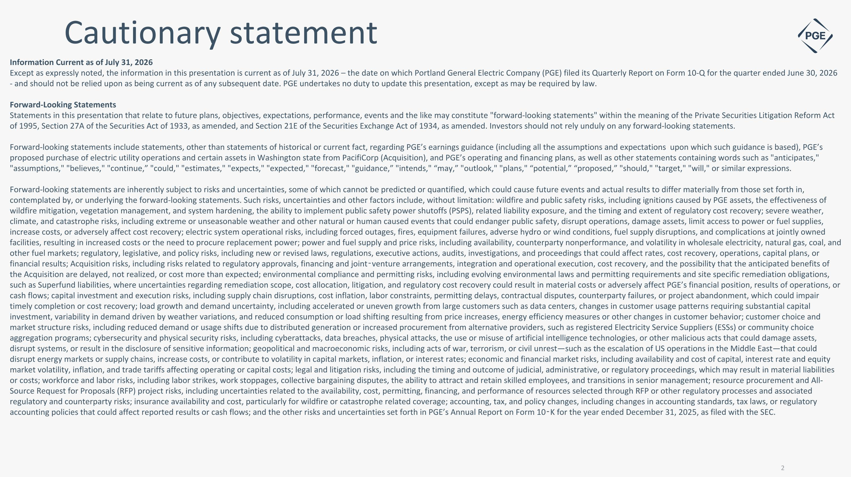
Cautionary statement Information Current as of July 31, 2026 Except as expressly noted, the information in this presentation is current as of July 31, 2026 – the date on which Portland General Electric Company (PGE) filed its Quarterly Report on Form 10-Q for the quarter ended June 30, 2026 - and should not be relied upon as being current as of any subsequent date. PGE undertakes no duty to update this presentation, except as may be required by law. Forward-Looking Statements Statements in this presentation that relate to future plans, objectives, expectations, performance, events and the like may constitute "forward-looking statements" within the meaning of the Private Securities Litigation Reform Act of 1995, Section 27A of the Securities Act of 1933, as amended, and Section 21E of the Securities Exchange Act of 1934, as amended. Investors should not rely unduly on any forward-looking statements. Forward-looking statements include statements, other than statements of historical or current fact, regarding PGE’s earnings guidance (including all the assumptions and expectations upon which such guidance is based), PGE’s proposed purchase of electric utility operations and certain assets in Washington state from PacifiCorp (Acquisition), and PGE’s operating and financing plans, as well as other statements containing words such as "anticipates," "assumptions," "believes," "continue,” "could," "estimates," "expects," "expected," "forecast," "guidance,” "intends," “may,” "outlook," "plans," “potential,” “proposed,” "should," "target," "will," or similar expressions. Forward-looking statements are inherently subject to risks and uncertainties, some of which cannot be predicted or quantified, which could cause future events and actual results to differ materially from those set forth in, contemplated by, or underlying the forward-looking statements. Such risks, uncertainties and other factors include, without limitation: wildfire and public safety risks, including ignitions caused by PGE assets, the effectiveness of wildfire mitigation, vegetation management, and system hardening, the ability to implement public safety power shutoffs (PSPS), related liability exposure, and the timing and extent of regulatory cost recovery; severe weather, climate, and catastrophe risks, including extreme or unseasonable weather and other natural or human caused events that could endanger public safety, disrupt operations, damage assets, limit access to power or fuel supplies, increase costs, or adversely affect cost recovery; electric system operational risks, including forced outages, fires, equipment failures, adverse hydro or wind conditions, fuel supply disruptions, and complications at jointly owned facilities, resulting in increased costs or the need to procure replacement power; power and fuel supply and price risks, including availability, counterparty nonperformance, and volatility in wholesale electricity, natural gas, coal, and other fuel markets; regulatory, legislative, and policy risks, including new or revised laws, regulations, executive actions, audits, investigations, and proceedings that could affect rates, cost recovery, operations, capital plans, or financial results; Acquisition risks, including risks related to regulatory approvals, financing and joint-venture arrangements, integration and operational execution, cost recovery, and the possibility that the anticipated benefits of the Acquisition are delayed, not realized, or cost more than expected; environmental compliance and permitting risks, including evolving environmental laws and permitting requirements and site specific remediation obligations, such as Superfund liabilities, where uncertainties regarding remediation scope, cost allocation, litigation, and regulatory cost recovery could result in material costs or adversely affect PGE’s financial position, results of operations, or cash flows; capital investment and execution risks, including supply chain disruptions, cost inflation, labor constraints, permitting delays, contractual disputes, counterparty failures, or project abandonment, which could impair timely completion or cost recovery; load growth and demand uncertainty, including accelerated or uneven growth from large customers such as data centers, changes in customer usage patterns requiring substantial capital investment, variability in demand driven by weather variations, and reduced consumption or load shifting resulting from price increases, energy efficiency measures or other changes in customer behavior; customer choice and market structure risks, including reduced demand or usage shifts due to distributed generation or increased procurement from alternative providers, such as registered Electricity Service Suppliers (ESSs) or community choice aggregation programs; cybersecurity and physical security risks, including cyberattacks, data breaches, physical attacks, the use or misuse of artificial intelligence technologies, or other malicious acts that could damage assets, disrupt systems, or result in the disclosure of sensitive information; geopolitical and macroeconomic risks, including acts of war, terrorism, or civil unrest—such as the escalation of US operations in the Middle East—that could disrupt energy markets or supply chains, increase costs, or contribute to volatility in capital markets, inflation, or interest rates; economic and financial market risks, including availability and cost of capital, interest rate and equity market volatility, inflation, and trade tariffs affecting operating or capital costs; legal and litigation risks, including the timing and outcome of judicial, administrative, or regulatory proceedings, which may result in material liabilities or costs; workforce and labor risks, including labor strikes, work stoppages, collective bargaining disputes, the ability to attract and retain skilled employees, and transitions in senior management; resource procurement and All-Source Request for Proposals (RFP) project risks, including uncertainties related to the availability, cost, permitting, financing, and performance of resources selected through RFP or other regulatory processes and associated regulatory and counterparty risks; insurance availability and cost, particularly for wildfire or catastrophe related coverage; accounting, tax, and policy changes, including changes in accounting standards, tax laws, or regulatory accounting policies that could affect reported results or cash flows; and the other risks and uncertainties set forth in PGE’s Annual Report on Form 10-K for the year ended December 31, 2025, as filed with the SEC.


Management participants Maria Pope President and CEO Joe Trpik SVP of Finance and CFO

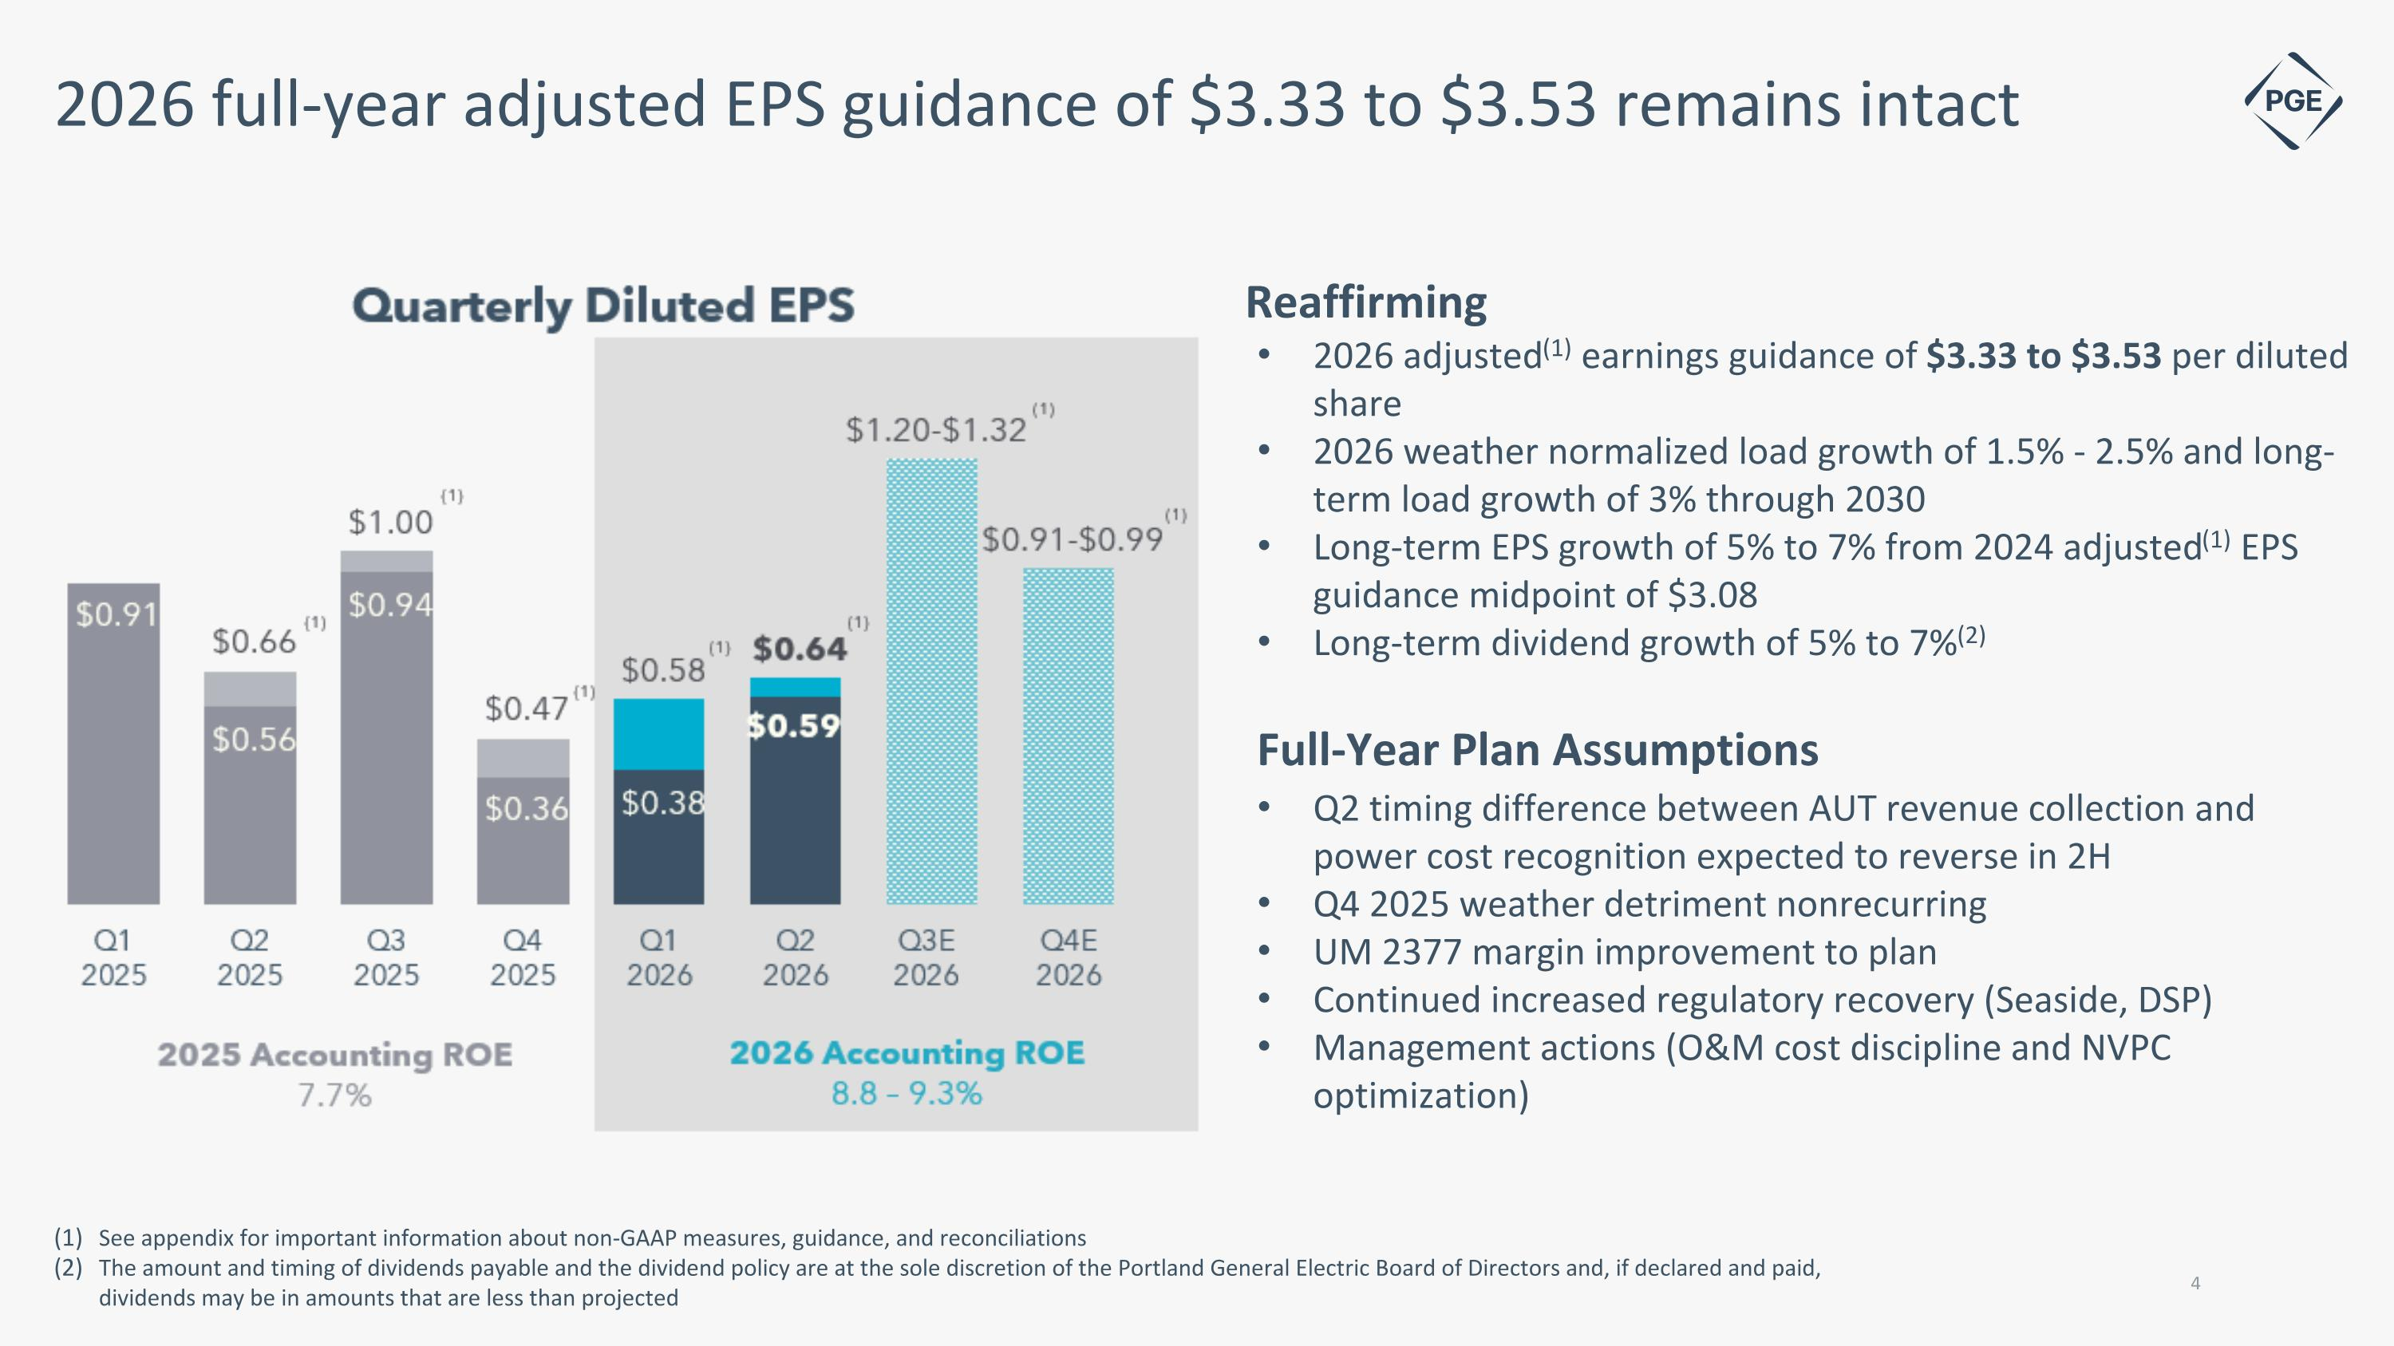
2026 full-year adjusted EPS guidance of $3.33 to $3.53 remains intact See appendix for important information about non-GAAP measures, guidance, and reconciliations The amount and timing of dividends payable and the dividend policy are at the sole discretion of the Portland General Electric Board of Directors and, if declared and paid, dividends may be in amounts that are less than projected Reaffirming 2026 adjusted(1) earnings guidance of $3.33 to $3.53 per diluted share 2026 weather normalized load growth of 1.5% - 2.5% and long-term load growth of 3% through 2030 Long-term EPS growth of 5% to 7% from 2024 adjusted(1) EPS guidance midpoint of $3.08 Long-term dividend growth of 5% to 7%(2) Full-Year Plan Assumptions Q2 timing difference between AUT revenue collection and power cost recognition expected to reverse in 2H Q4 2025 weather detriment nonrecurring UM 2377 margin improvement to plan Continued increased regulatory recovery (Seaside, DSP) Management actions (O&M cost discipline and NVPC optimization)

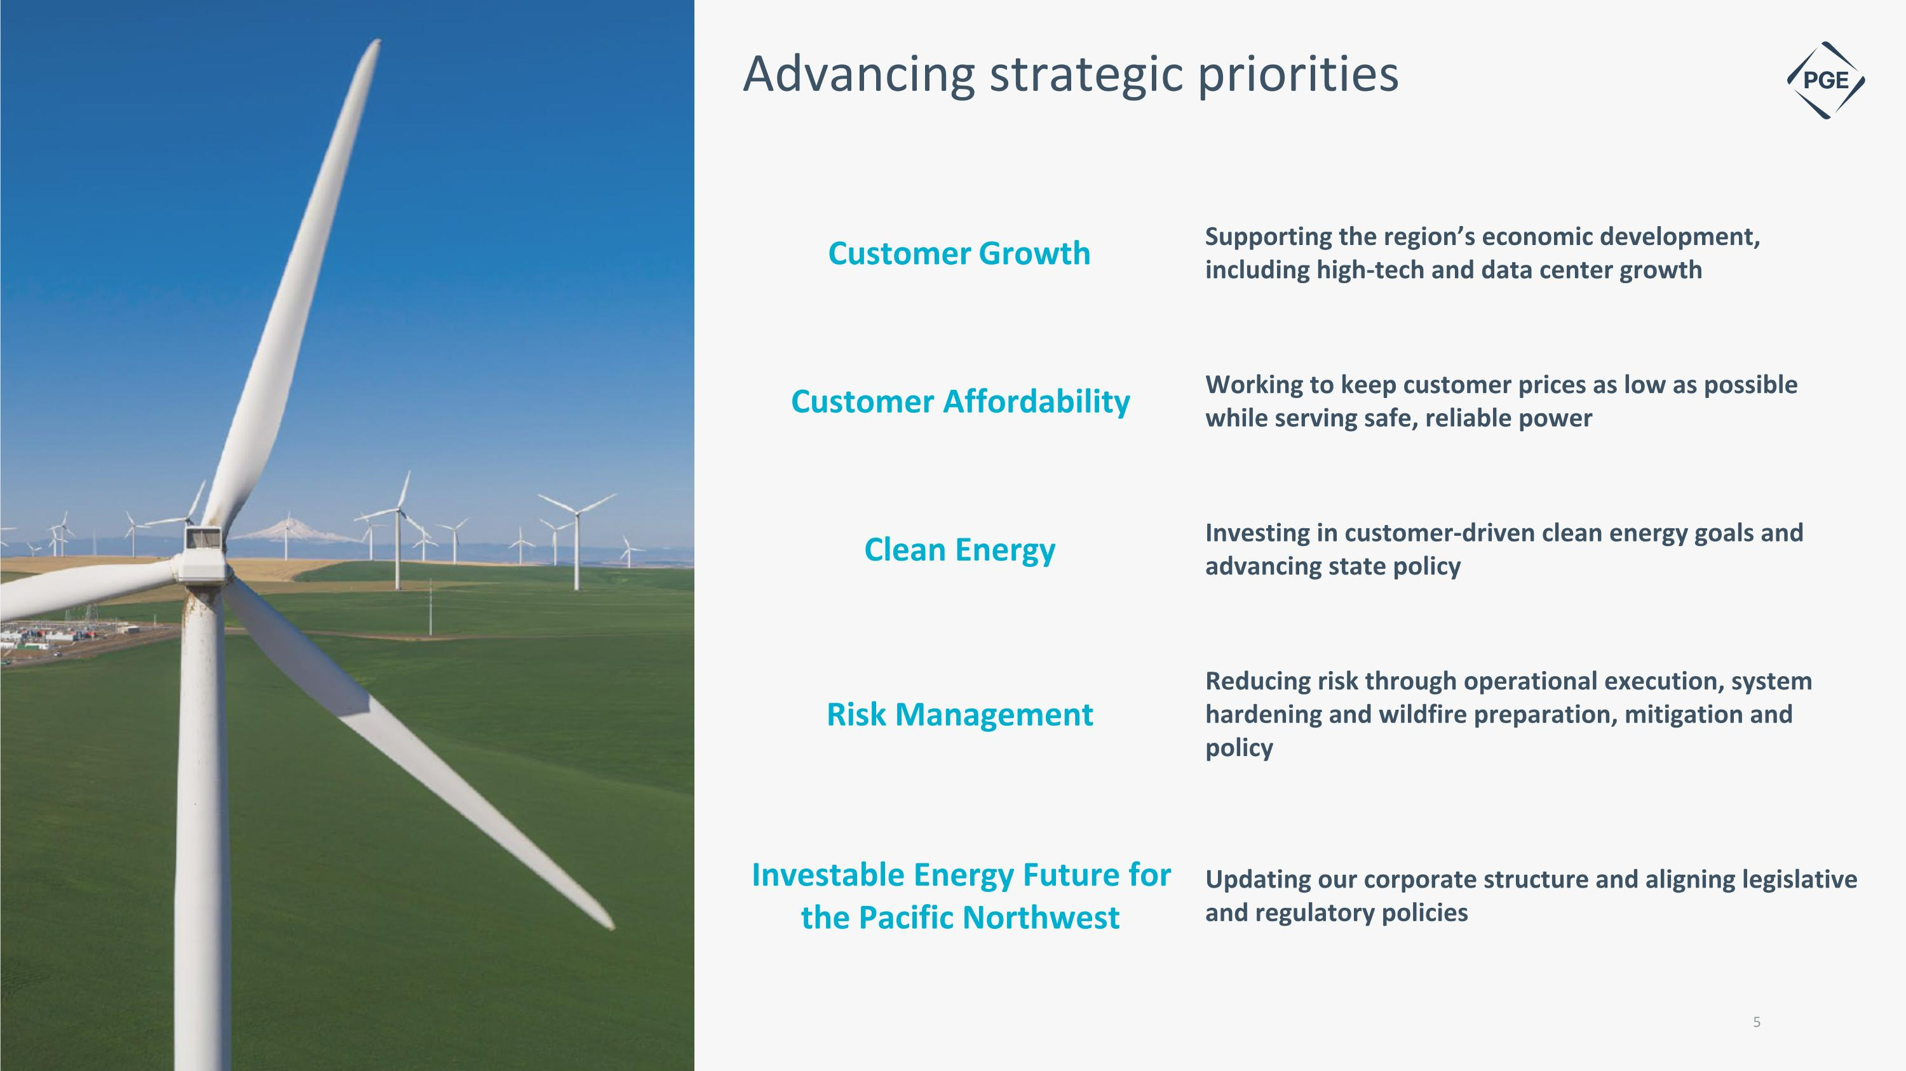
Advancing strategic priorities Customer Growth Supporting the region’s economic development, including high-tech and data center growth Customer Affordability Working to keep customer prices as low as possible while serving safe, reliable power Clean Energy Investing in customer-driven clean energy goals and advancing state policy Risk Management Reducing risk through operational execution, system hardening and wildfire preparation, mitigation and policy Investable Energy Future for the Pacific Northwest Updating our corporate structure and aligning legislative and regulatory policies

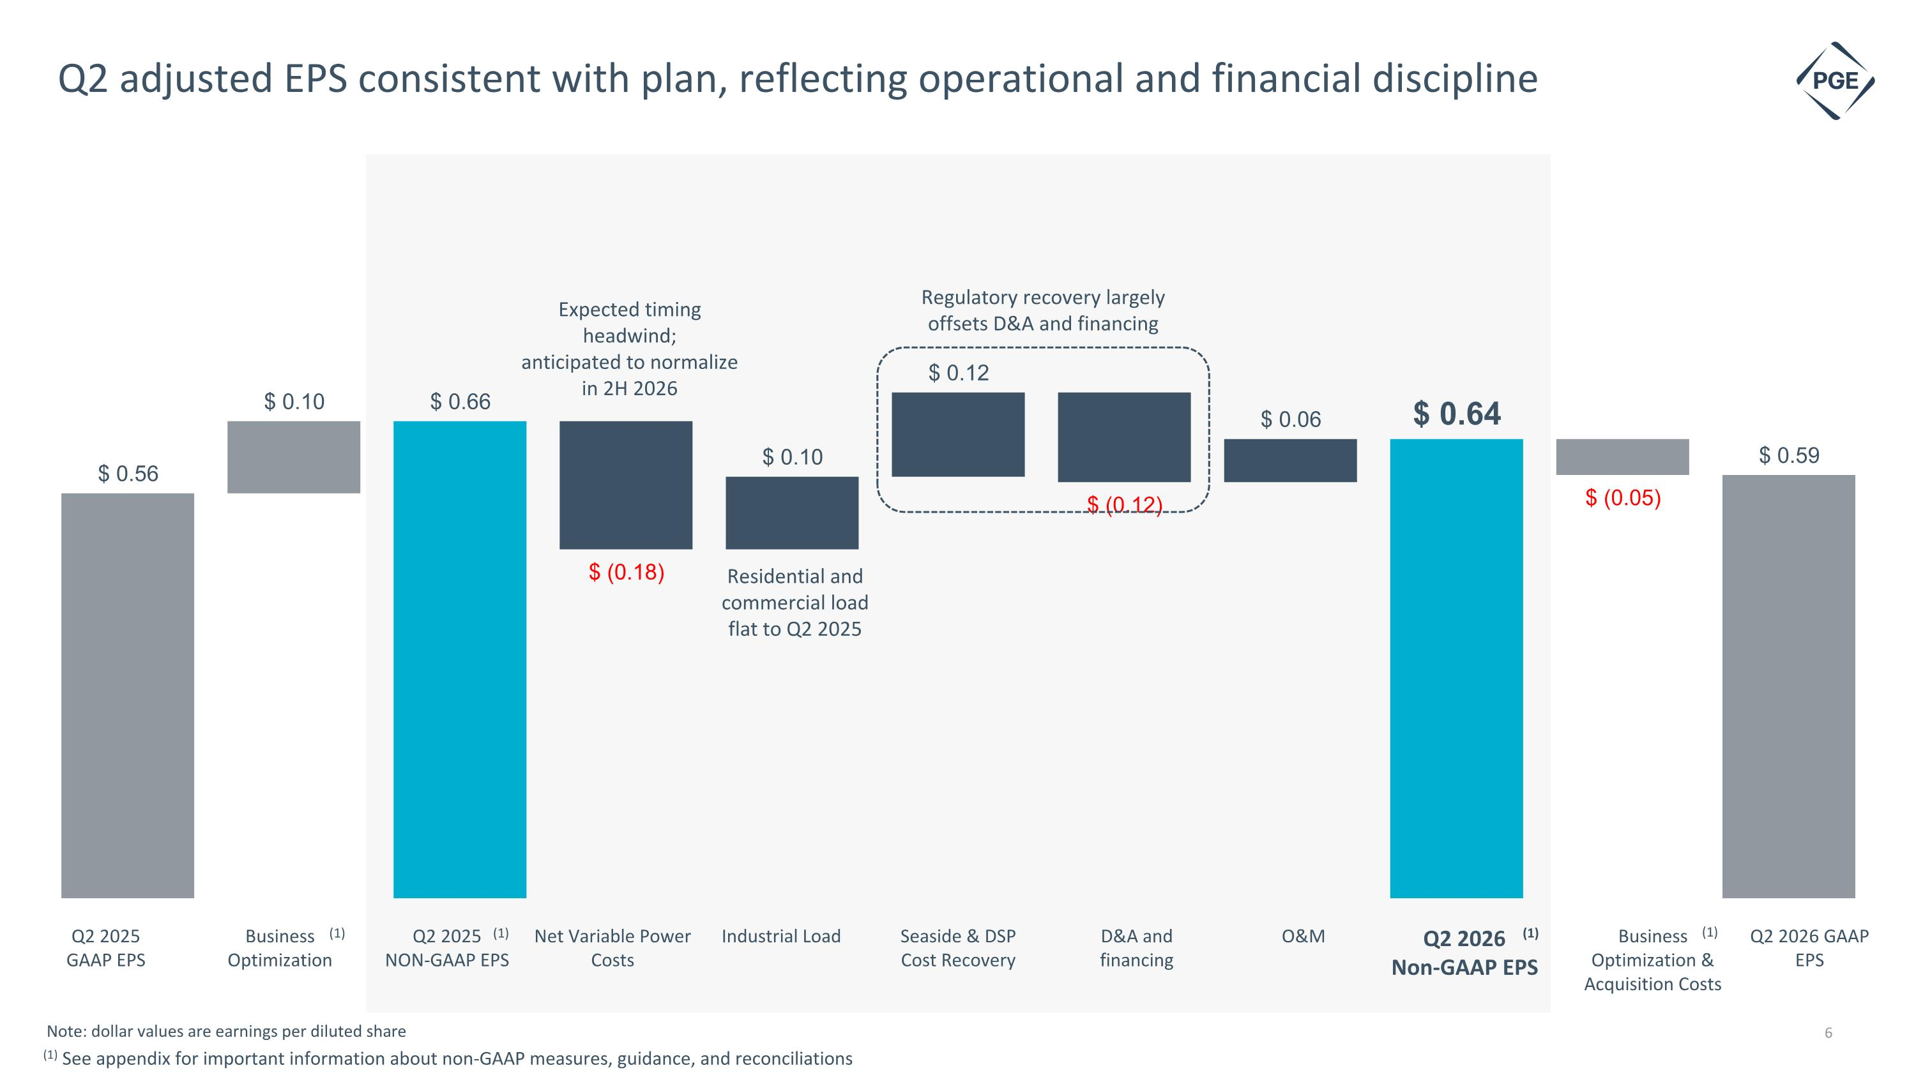
Q2 adjusted EPS consistent with plan, reflecting operational and financial discipline Q2 2026 GAAP EPS Q2 2025 GAAP EPS O&M Q2 2026 Non-GAAP EPS Business Optimization & Acquisition Costs D&A and financing Business Optimization Net Variable Power Costs Industrial Load Expected timing headwind; anticipated to normalize in 2H 2026 Note: dollar values are earnings per diluted share Q2 2025 NON-GAAP EPS Seaside & DSP Cost Recovery Residential and commercial load flat to Q2 2025 Regulatory recovery largely offsets D&A and financing (1) (1) (1) (1) (1) See appendix for important information about non-GAAP measures, guidance, and reconciliations 6

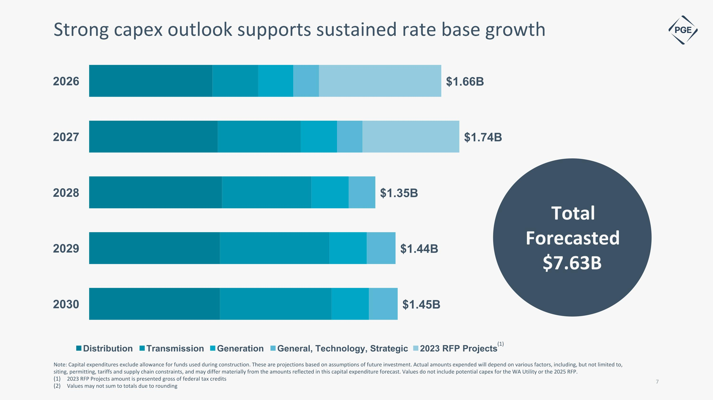
Note: Capital expenditures exclude allowance for funds used during construction. These are projections based on assumptions of future investment. Actual amounts expended will depend on various factors, including, but not limited to, siting, permitting, tariffs and supply chain constraints, and may differ materially from the amounts reflected in this capital expenditure forecast. Values do not include potential capex for the WA Utility or the 2025 RFP. 2023 RFP Projects amount is presented gross of federal tax credits Values may not sum to totals due to rounding Strong capex outlook supports sustained rate base growth Total Forecasted $7.63B (1)

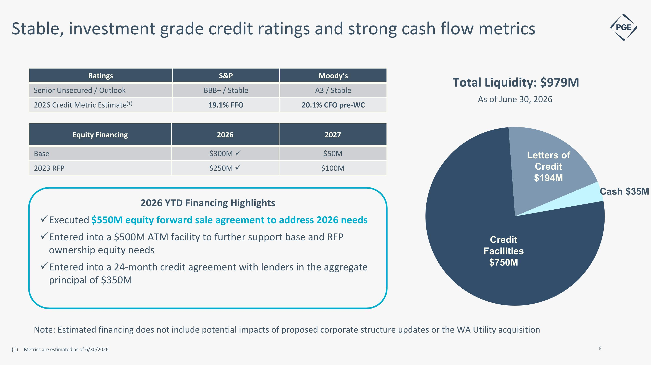
Ratings S&P Moody’s Senior Unsecured / Outlook BBB+ / Stable A3 / Stable 2026 Credit Metric Estimate(1) 19.1% FFO 20.1% CFO pre-WC Stable, investment grade credit ratings and strong cash flow metrics Metrics are estimated as of 6/30/2026 Equity Financing 2026 2027 Base $300M ✓ $50M 2023 RFP $250M ✓ $100M 2026 YTD Financing Highlights Executed $550M equity forward sale agreement to address 2026 needs Entered into a $500M ATM facility to further support base and RFP ownership equity needs Entered into a 24-month credit agreement with lenders in the aggregate principal of $350M Note: Estimated financing does not include potential impacts of proposed corporate structure updates or the WA Utility acquisition


Appendix

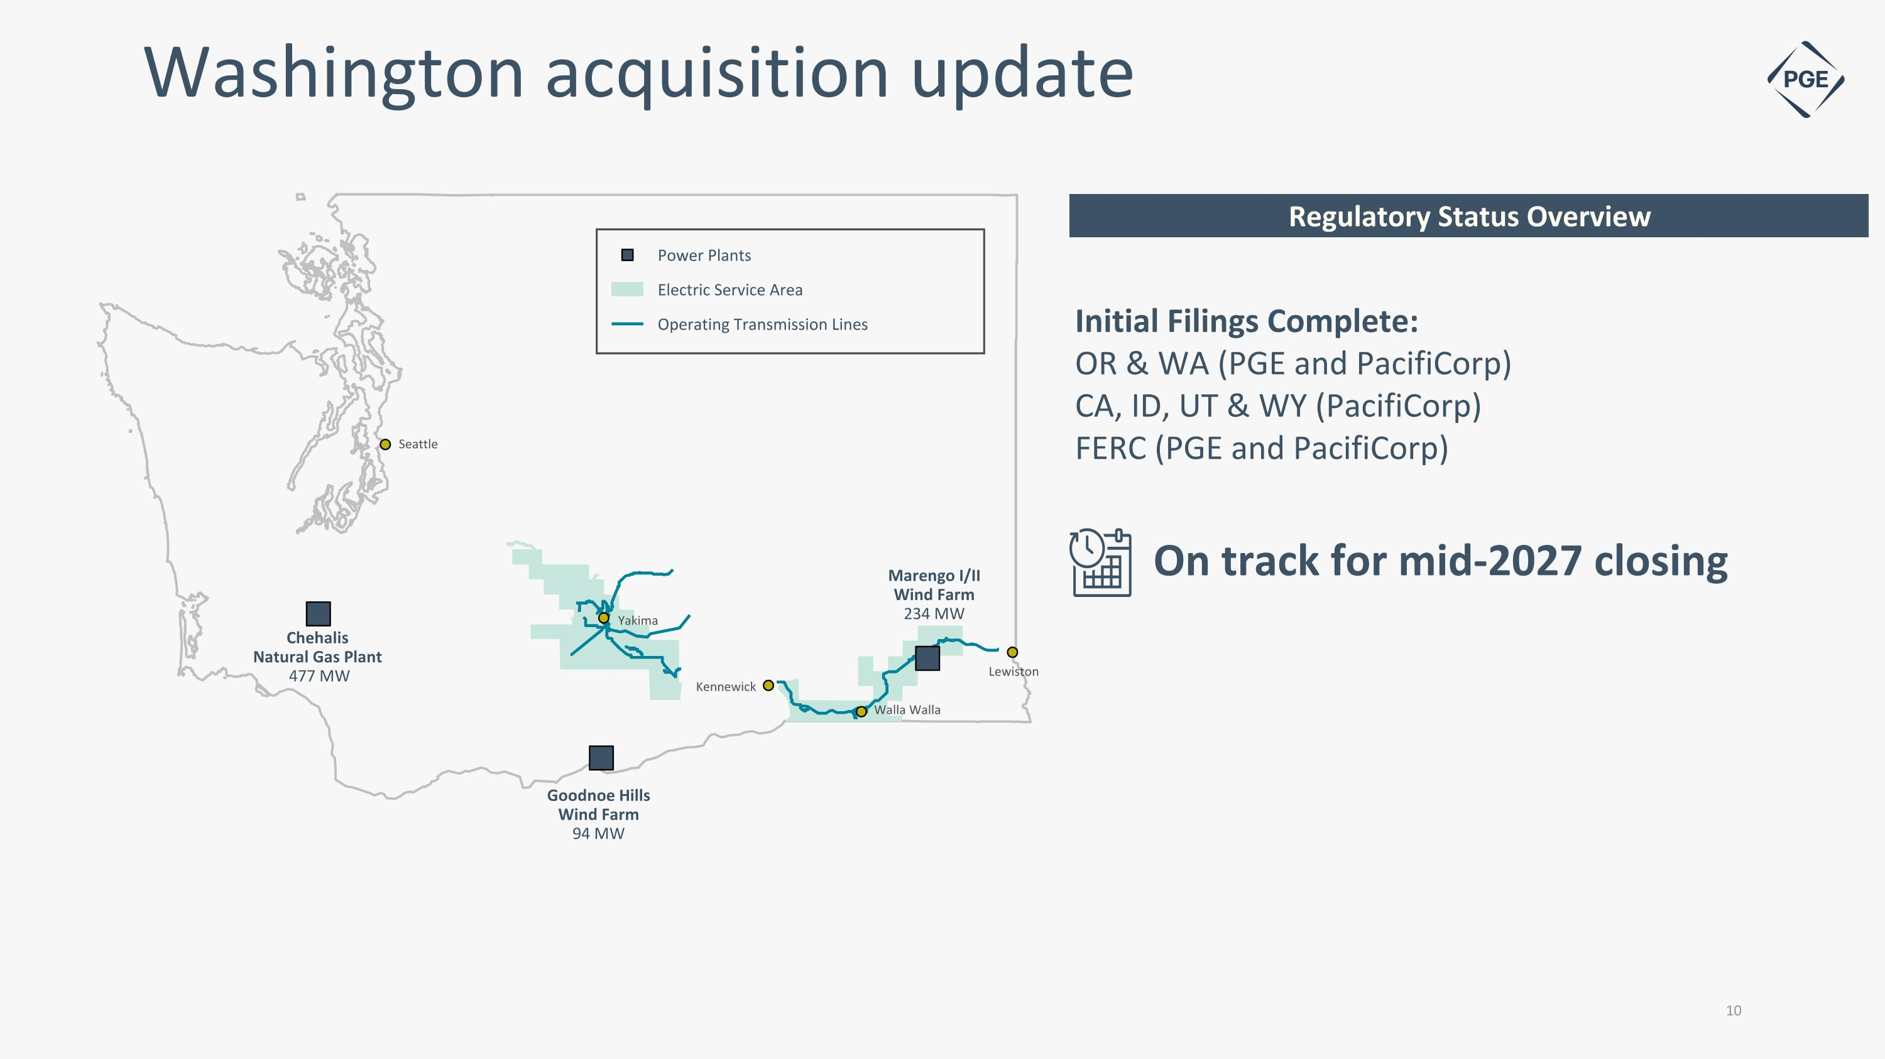
Washington acquisition update Regulatory Status Overview 10 Electric Service Area Operating Transmission Lines Power Plants Chehalis Natural Gas Plant 477 MW Seattle Goodnoe Hills?Wind Farm 94 MW Marengo I/II?Wind Farm 234 MW Lewiston Walla Walla Kennewick Yakima Initial Filings Complete: OR & WA (PGE and PacifiCorp) CA, ID, UT & WY (PacifiCorp) FERC (PGE and PacifiCorp) On track for mid-2027 closing

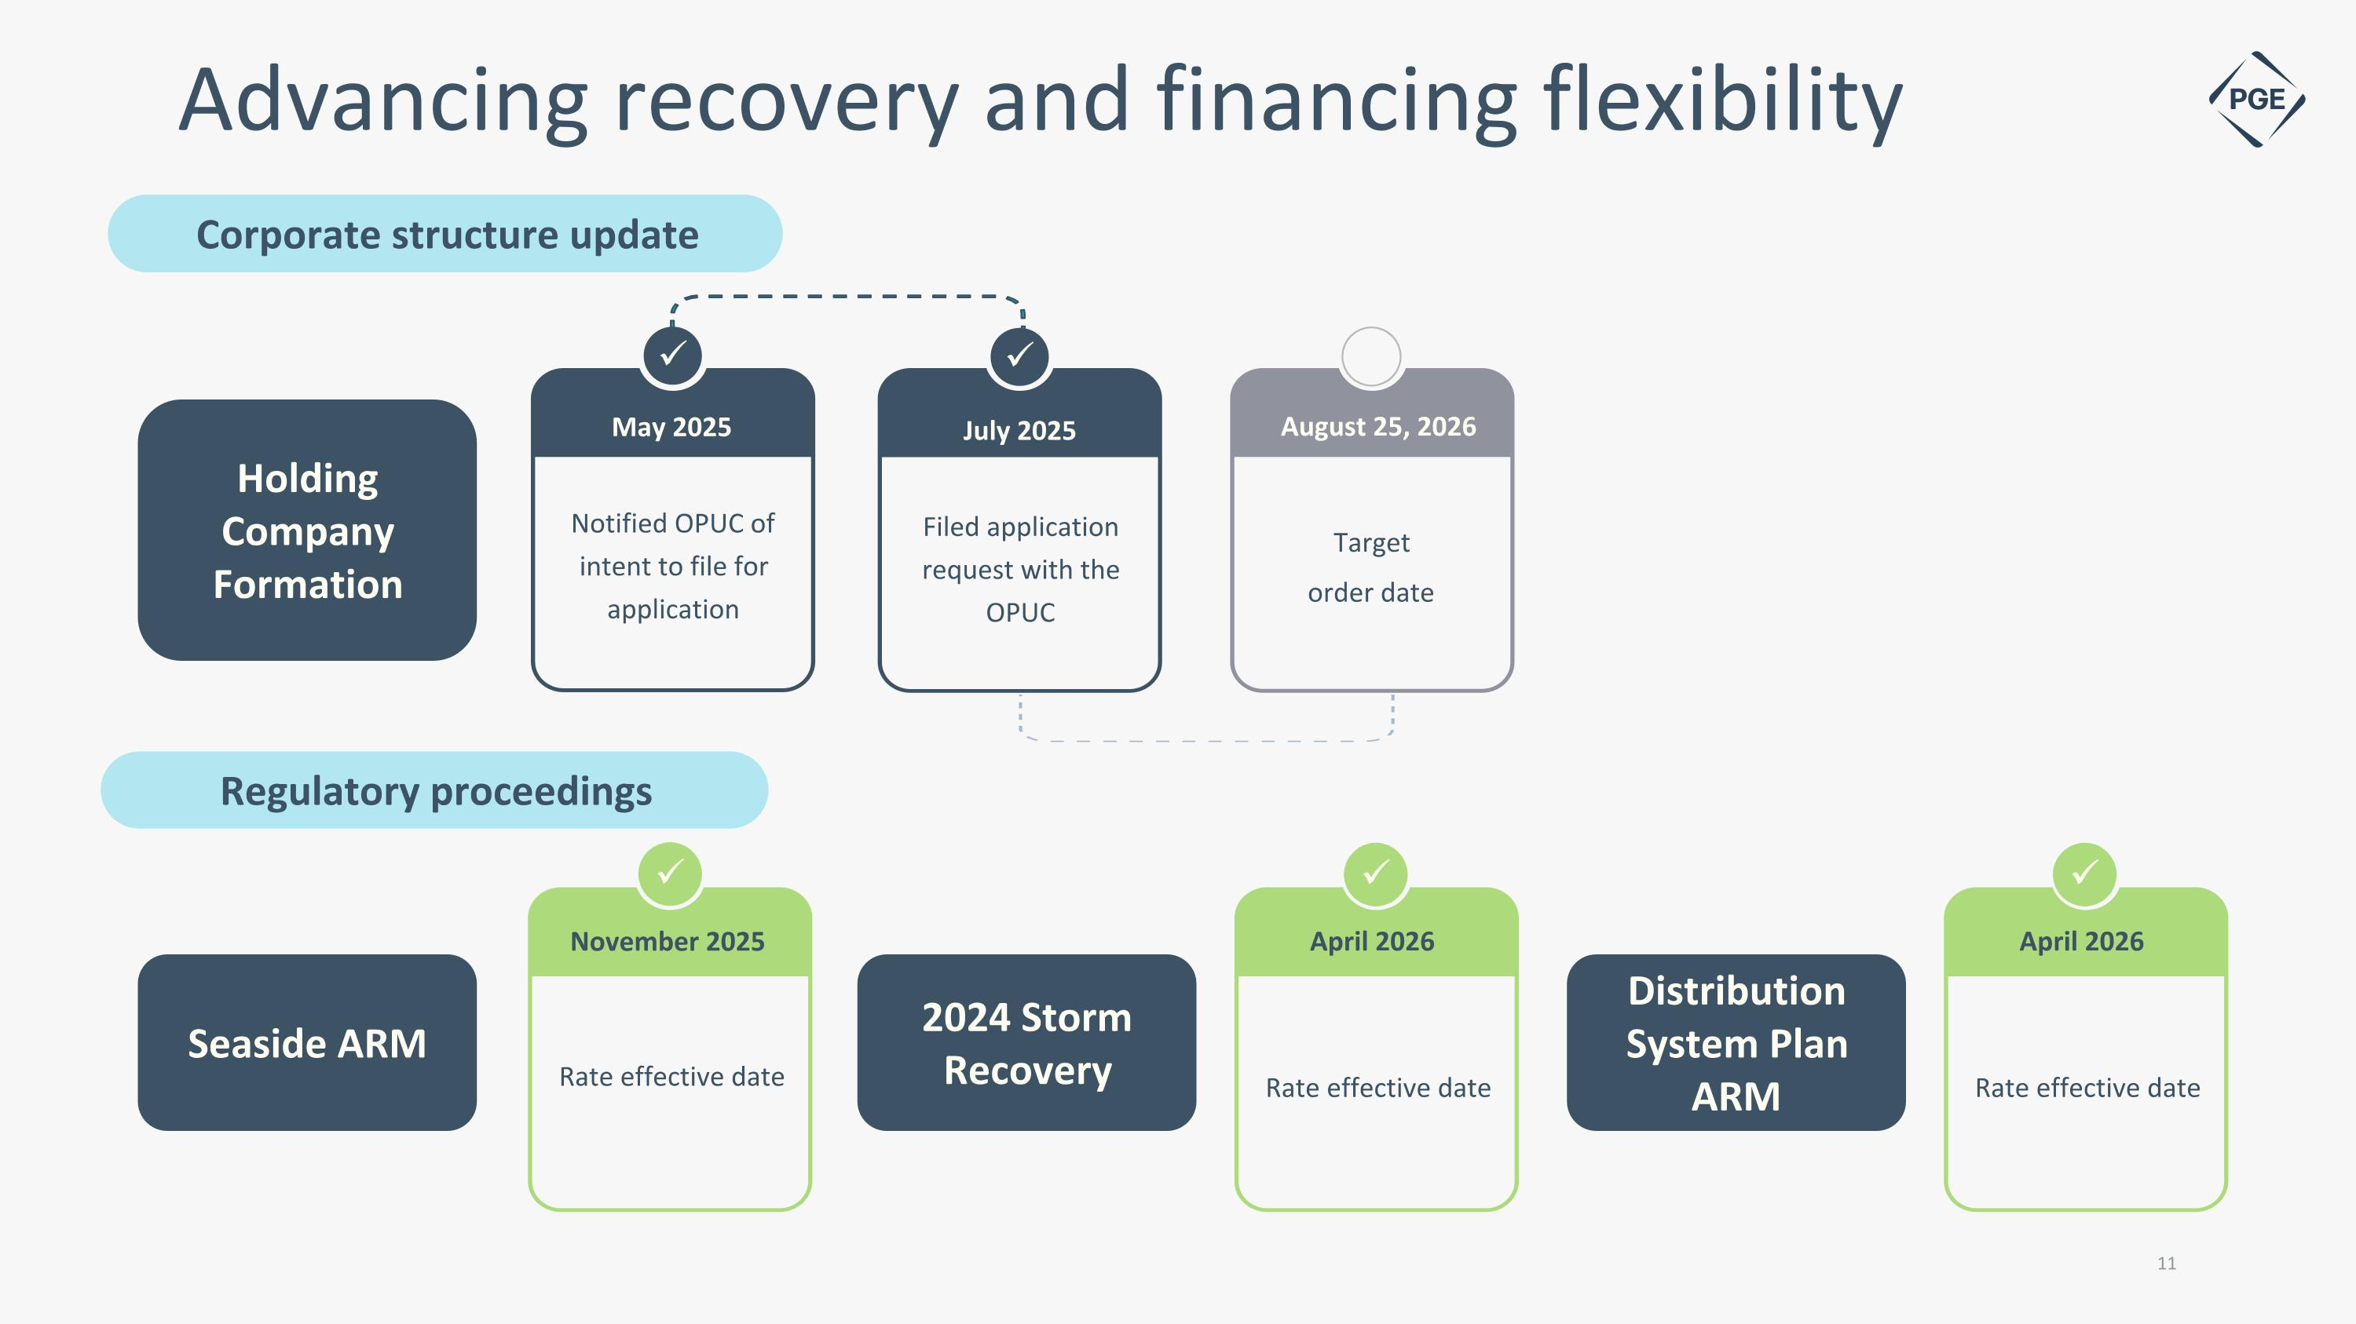
Rate effective date November 2025 Rate effective date April 2026 Advancing recovery and financing flexibility Regulatory proceedings 11 ✓ 2024 Storm Recovery Seaside ARM ✓ Corporate structure update ✓ ✓ Notified OPUC of intent to file for application May 2025 Filed application request with the OPUC July 2025 Target order date August 25, 2026 Holding Company Formation Rate effective date April 2026 Distribution System Plan ARM ✓

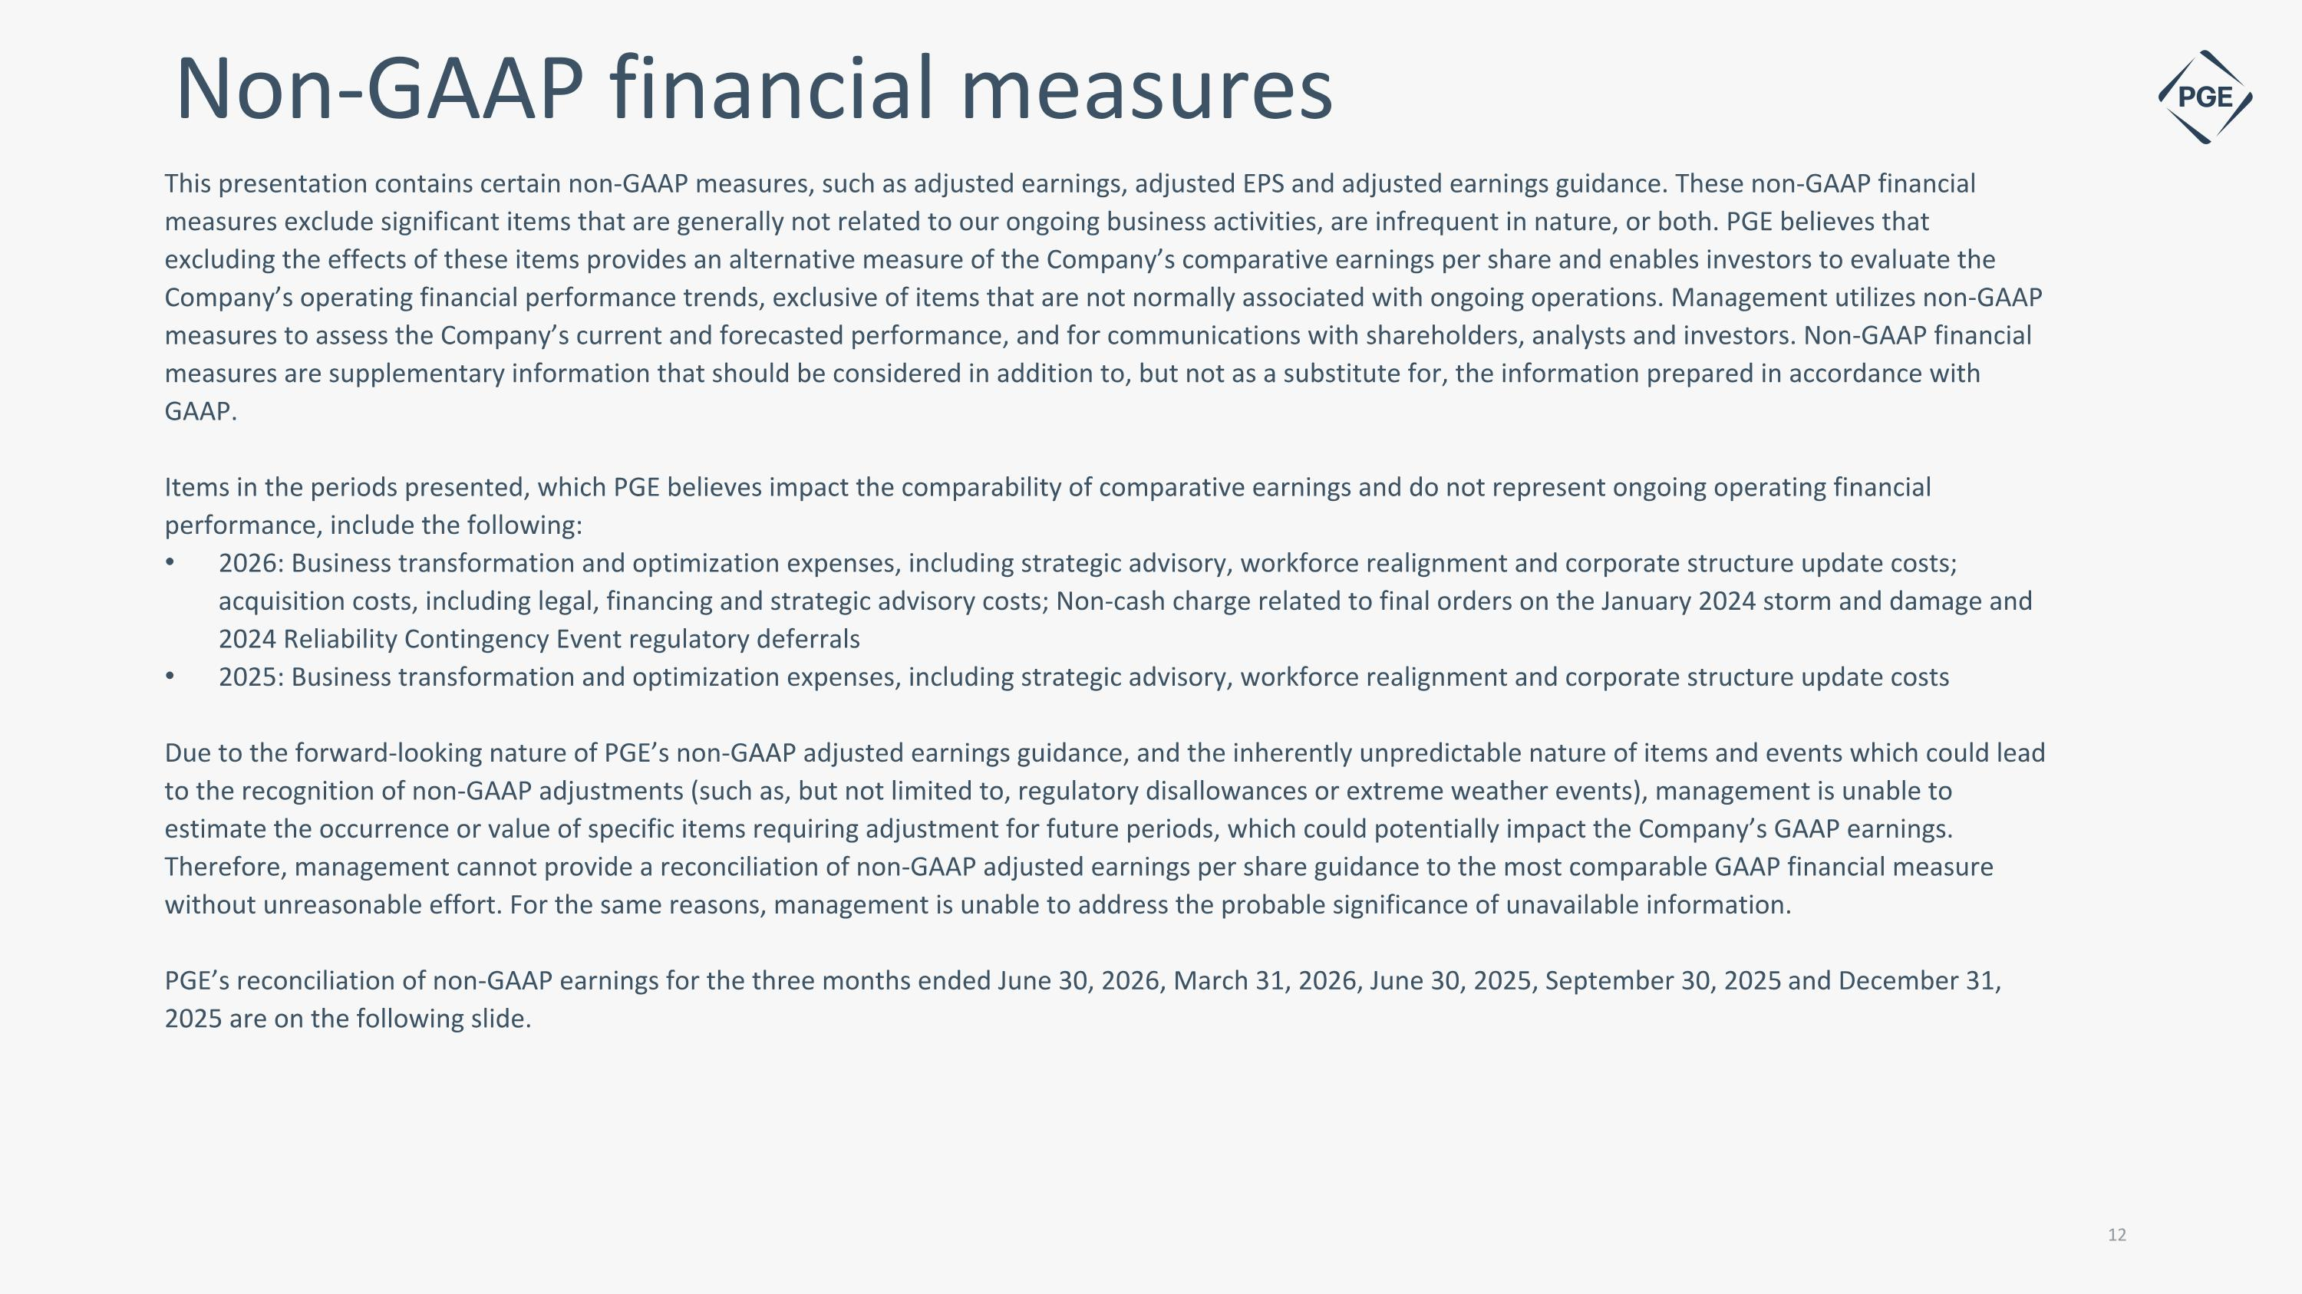
This presentation contains certain non-GAAP measures, such as adjusted earnings, adjusted EPS and adjusted earnings guidance. These non-GAAP financial measures exclude significant items that are generally not related to our ongoing business activities, are infrequent in nature, or both. PGE believes that excluding the effects of these items provides an alternative measure of the Company’s comparative earnings per share and enables investors to evaluate the Company’s operating financial performance trends, exclusive of items that are not normally associated with ongoing operations. Management utilizes non-GAAP measures to assess the Company’s current and forecasted performance, and for communications with shareholders, analysts and investors. Non-GAAP financial measures are supplementary information that should be considered in addition to, but not as a substitute for, the information prepared in accordance with GAAP. Items in the periods presented, which PGE believes impact the comparability of comparative earnings and do not represent ongoing operating financial performance, include the following: 2026: Business transformation and optimization expenses, including strategic advisory, workforce realignment and corporate structure update costs; acquisition costs, including legal, financing and strategic advisory costs; Non-cash charge related to final orders on the January 2024 storm and damage and 2024 Reliability Contingency Event regulatory deferrals 2025: Business transformation and optimization expenses, including strategic advisory, workforce realignment and corporate structure update costs Due to the forward-looking nature of PGE’s non-GAAP adjusted earnings guidance, and the inherently unpredictable nature of items and events which could lead to the recognition of non-GAAP adjustments (such as, but not limited to, regulatory disallowances or extreme weather events), management is unable to estimate the occurrence or value of specific items requiring adjustment for future periods, which could potentially impact the Company’s GAAP earnings. Therefore, management cannot provide a reconciliation of non-GAAP adjusted earnings per share guidance to the most comparable GAAP financial measure without unreasonable effort. For the same reasons, management is unable to address the probable significance of unavailable information. PGE’s reconciliation of non-GAAP earnings for the three months ended June 30, 2026, March 31, 2026, June 30, 2025, September 30, 2025 and December 31, 2025 are on the following slide. Non-GAAP financial measures

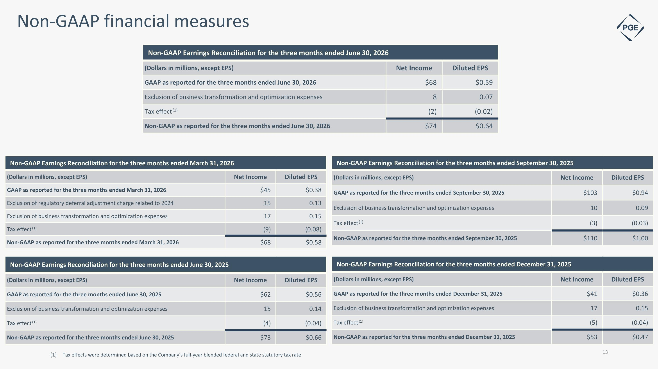
Non-GAAP Earnings Reconciliation for the three months ended March 31, 2026 (Dollars in millions, except EPS) Net Income Diluted EPS GAAP as reported for the three months ended March 31, 2026 $45 $0.38 Exclusion of regulatory deferral adjustment charge related to 2024 15 0.13 Exclusion of business transformation and optimization expenses 17 0.15 Tax effect (1) (9) (0.08) Non-GAAP as reported for the three months ended March 31, 2026 $68 $0.58 Non-GAAP financial measures Tax effects were determined based on the Company’s full-year blended federal and state statutory tax rate Non-GAAP Earnings Reconciliation for the three months ended June 30, 2025 (Dollars in millions, except EPS) Net Income Diluted EPS GAAP as reported for the three months ended June 30, 2025 $62 $0.56 Exclusion of business transformation and optimization expenses 15 0.14 Tax effect (1) (4) (0.04) Non-GAAP as reported for the three months ended June 30, 2025 $73 $0.66 Non-GAAP Earnings Reconciliation for the three months ended December 31, 2025 (Dollars in millions, except EPS) Net Income Diluted EPS GAAP as reported for the three months ended December 31, 2025 $41 $0.36 Exclusion of business transformation and optimization expenses 17 0.15 Tax effect (1) (5) (0.04) Non-GAAP as reported for the three months ended December 31, 2025 $53 $0.47 Non-GAAP Earnings Reconciliation for the three months ended September 30, 2025 (Dollars in millions, except EPS) Net Income Diluted EPS GAAP as reported for the three months ended September 30, 2025 $103 $0.94 Exclusion of business transformation and optimization expenses 10 0.09 Tax effect (1) (3) (0.03) Non-GAAP as reported for the three months ended September 30, 2025 $110 $1.00 Non-GAAP Earnings Reconciliation for the three months ended June 30, 2026 (Dollars in millions, except EPS) Net Income Diluted EPS GAAP as reported for the three months ended June 30, 2026 $68 $0.59 Exclusion of business transformation and optimization expenses 8 0.07 Tax effect (1) (2) (0.02) Non-GAAP as reported for the three months ended June 30, 2026 $74 $0.64

